NUMBER | Service Number | NAME | Surname
RANK | Rct | SUB-UNIT | Pirbright

1. DISPOSAL

FIT FOR FULL DUTIES

TRG LIMITATIONS |  | For |  | Days | Or until

ENTRY DEFERRED AT IMA | X | For |  | wks | Or until

2. LIMITATIONS

X = EXCUSED |  | N/A = Not applicable
= PERMITTED

Rct Surname's body composition measured today during their Initial Medical Assessment does not meet the standard required by AGAI 40.

JSP 950 6-7-7 Section 3 Annex C states "The health effects of being underweight or overweight are well known. However, the overall fitness and functional capacity of the individual should also be considered. For example, some individuals, such as body builders, who are lean but have a high BMI due to a high lean body mass, may be suitable for service. However, there is clear evidence that there is a significantly increased risk of musculoskeletal injury (particularly during military training and in females) in those with a low BMI. Similarly, there is evidence that in individuals with a high BMI there is decreased muscle endurance and an associated increase in fatigue."

The CoC are therefore advised to determine if Rct Surname should be discharged as a Defect in Enlistment (AF B204) due to their body composition, or whether they remain here (if so they must meet this standard to be graded MFD at a subsequent IMA). Please inform the medical centre of the CoC's decision.

CURRENT MEASUREMENTS
Weight Read Code Fields - 22A kg
Height Read Code Fields - 229 cm
BMI Read Code Fields - 22K kg/m²
Waist Circumference Read Code Fields - 22N0 cm

AGAI 40 Standards:
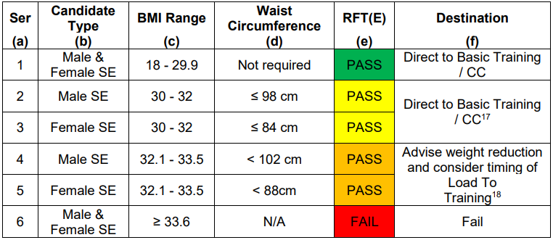

Recruits who are under 18 must have a BMI of 17 - 29.9. They are not eligible for waist circumference adjustment or SDC loading.

NAME AND RANK | User Title User Name | DATE | System Date
SIGNATURE |  | EXT
PLATOON/TROOP STAFF SIGNATURE |  | DATE
RECRUIT’S SIGNATURE |  | DATE

Practice Address Stacked | UNIT STAMP | IMPORTANT
Practice Address Stacked |  | Sub-unit staff are responsible for ensuring recruits are aware of and attend all medical appointments

